Print PostOrder from Pre and InOrder

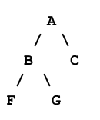**Summary:**

Given a binary tree of non-repeated characters. The program has a function **printPostOrder** that takes two strings represented in the preorder traversal and the in-order traversal of the tree. Then the function prints the post-order traversal.   
Example: **printPostOrder("ABFGC", "FBGAC")** => **FGBCA**

The project is built using **C++, Visual Studio**.